

Database Management  
System LAB

**Project Report**

|  |  |
| --- | --- |
| Group Members: |  |
| Program: | BSSE |
| Section: | 4-A |

**Lab Instructor:**

Table of Contents

Hotel Booking Management System 3

**1. Introduction** 3

2. Motivation 3

3. Table Structures and Columns 3

Hotels 3

**Rooms** 3

**Customers** 4

**Bookings** 4

**Reviews** 4

**Staff** 5

**4. Screenshots and Evidence** 5

**-Table Creation in MySQL** 5

**- Data Insertion using (LOAD DATA INFILE TO IMPORT DATA FROM CSV FILES TO THE TABLES)** 6

**- Sample Aggregate Queries** 6

**- JOINs and Subqueries** 8

**- Transactions and Indexing** 10

**- Procedures** 12

**- Views** 13

**5. Key SQL Concepts Demonstrated** 15

**6. SQL Script Best Practices** 15

**7. Conclusion** 15

# Hotel Booking Management System

# 

**1. Introduction**

The **Hotel Booking Management System** is a relational database project designed to simulate real-world hotel operations. It manages room bookings, customer information, payments, reviews, and staff data. The project emphasizes performance optimization using indexing, constraints, and normalization.

The dataset also includes realistic data inconsistencies such as NULL values and duplicate entries to reflect real-world conditions and to test query robustness.

## 2. Motivation

The hotel industry deals with large volumes of daily data. Manual processes are inefficient and prone to error. This project was initiated to:

* Efficiently manage room availability and bookings
* Simulate real-time data analytics with SQL
* Ensure ACID-compliant transaction handling
* Test SQL proficiency using large and inconsistent datasets

## 3. Table Structures and Columns

### Hotels

* Hotel_ID **(Primary Key)**
* Name
* Location
* Rating
* Contact_Email
* Contact_Number

**Rooms**

* Room_ID (Primary Key)
* Hotel_ID (Foreign Key → Hotels)
* Room_Type
* Room_Number
* Price_Per_Night
* Availability Status

**Customers**

* Customer_ID (Primary Key)
* Full_Name
* Email
* Phone_Number
* Address
* Nationality
* CNIC/Passport_Number

**Bookings**

* Booking_ID (Primary Key)
* Room_ID (Foreign Key → Rooms)
* Customer_ID (Foreign Key → Customers)
* Check_IN_Date
* Check_Out_Date
* Num_guests
* Payment Status

**Reviews**

* Review_ID (Primary Key)
* Hotel_ID (Foreign Key → Hotels)
* Customer_ID (Foreign Key → Customers)
* Rating
* Comment
* Review Date

**Staff**

* Staff_ID (Primary Key)
* Hotel_ID (Foreign Key → Hotels)
* Full_Name
* Designation
* Salary
* Hire_Date

**4. Screenshots and Evidence**

**-Table Creation in MySQL**

**Query:**

create table hotels (

hotel_id int primary key auto_increment,

name varchar(100) not null,

location varchar(100),

star_rating int check (star_rating between 1 and 5),

contact_email varchar(100) unique,

contact_number varchar(100)

);

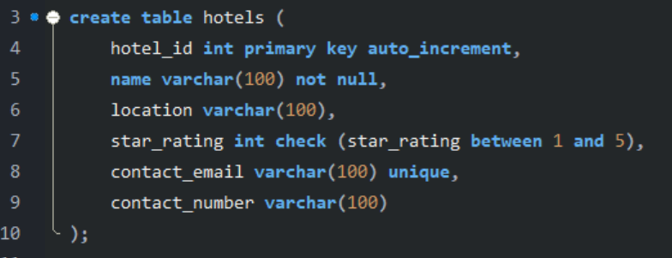

**Output:**

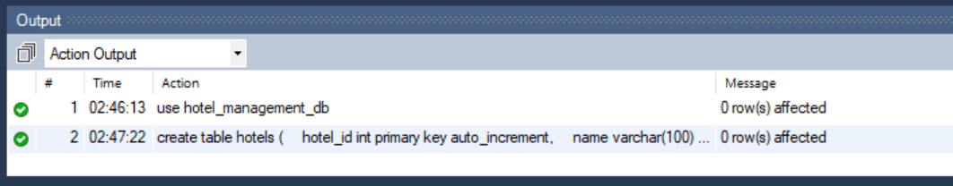

**- Data Insertion using (LOAD DATA INFILE TO IMPORT DATA FROM CSV FILES TO THE TABLES)**

**Query:**

LOAD DATA INFILE 'C:/ProgramData/MySQL/MySQL Server 8.0/Uploads/hotels.csv'

INTO TABLE hotels

FIELDS TERMINATED BY ','

ENCLOSED BY '"'

LINES TERMINATED BY '\n'

IGNORE 1 ROWS;

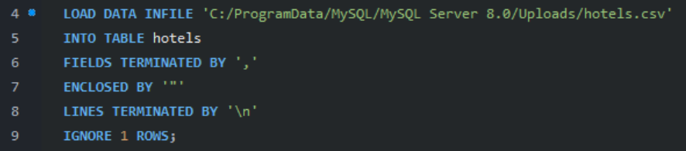

**Output:**

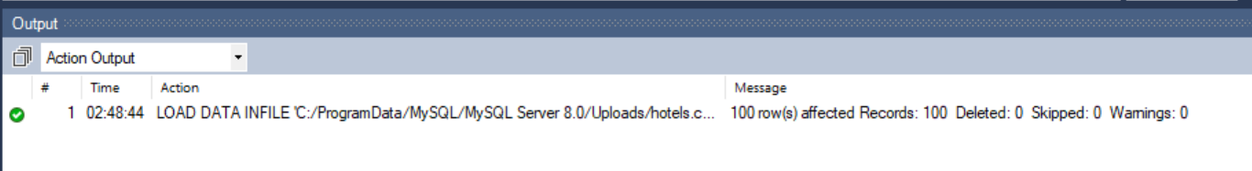

**- Sample Aggregate Queries**

**Query:**

SELECT availability_status, COUNT(*) AS total_rooms

FROM rooms

GROUP BY availability_status;

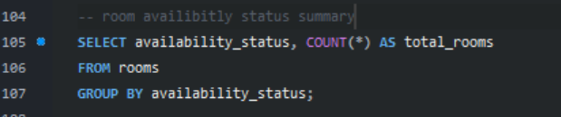

**Output:**

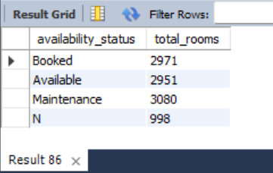

**Query:**

SELECT COUNT(DISTINCT room_type) AS unique_room_types

FROM rooms;



**Output:**

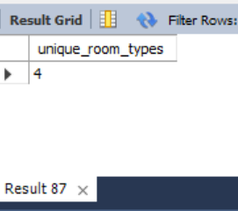

**Query:**

SELECT AVG(num_guests) AS avg_guests_per_booking

FROM bookings;

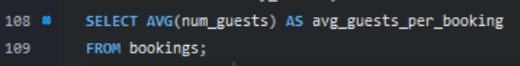

**Output:**

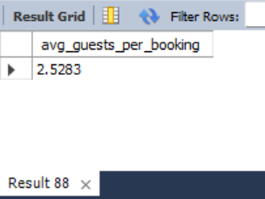

**- JOINs and Subqueries**

**Query:**

SELECT h.name AS hotel_name, AVG(r.price_per_night) AS average_price

FROM hotels h

JOIN rooms r ON h.hotel_id = r.hotel_id

GROUP BY h.hotel_id, h.name;

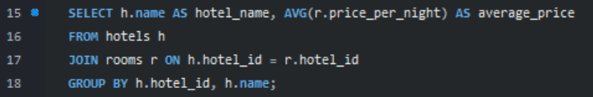

**Output:**

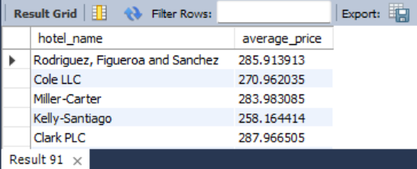

**Query:**

SELECT h.name AS hotel_name,round(AVG(rv.rating),2) AS average_rating

FROM hotels h

JOIN reviews rv ON h.hotel_id = rv.hotel_id

GROUP BY h.hotel_id, h.name;

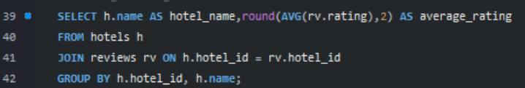

**Output:**

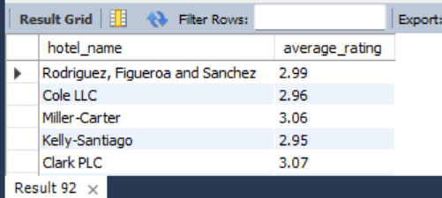

**Query:**

SELECT hotel_id,name

FROM hotels

WHERE hotel_id IN (

SELECT hotel_id

FROM reviews

GROUP BY hotel_id

HAVING AVG(rating) > (

SELECT AVG(rating) FROM reviews

)

);

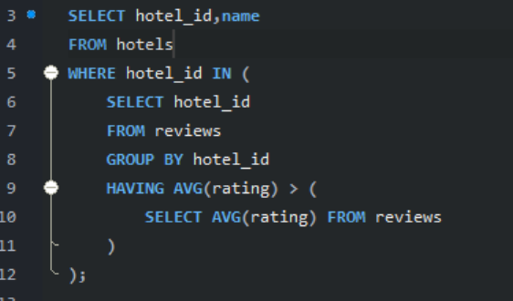

**Output:**

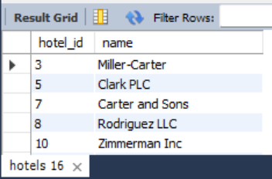

**Query:**

SELECT * FROM customers

WHERE customer_id IN (

SELECT customer_id

FROM bookings

GROUP BY customer_id

HAVING COUNT(*) > 2

);

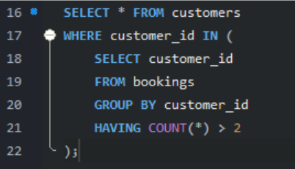

**Output:**

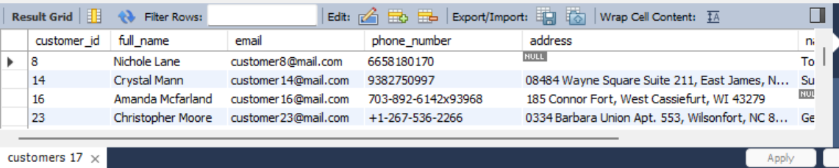

**- Transactions and Indexing**

**Query:**

START TRANSACTION;

INSERT INTO customers (full_name, email, phone_number)

VALUES ('John Doe', 'john@example.com', '1234567890');

COMMIT;

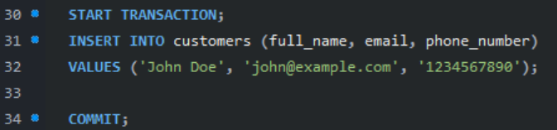

**Output:**

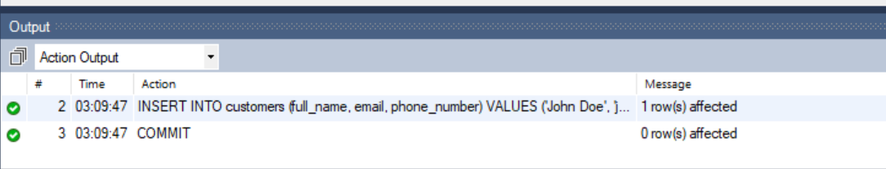

**Query:**

SET TRANSACTION ISOLATION LEVEL READ COMMITTED;

START TRANSACTION;

SELECT * FROM rooms WHERE room_id = 1 AND availability_status = 'available' FOR UPDATE;

COMMIT;

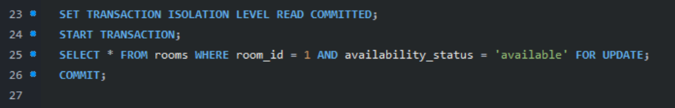

**Output:**

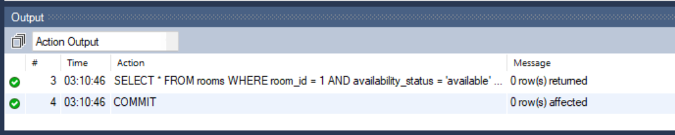

**Query:**

CREATE INDEX idx_rooms_hotel ON rooms(hotel_id);

CREATE INDEX idx_bookings_customer ON bookings(customer_id);

CREATE INDEX idx_bookings_room ON bookings(room_id);

CREATE INDEX idx_bookings_checkin ON bookings(check_in_date);

CREATE INDEX idx_reviews_hotel ON reviews(hotel_id);

CREATE INDEX idx_staff_hotel ON staff(hotel_id);

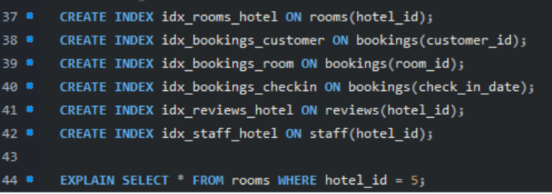

**Output:**

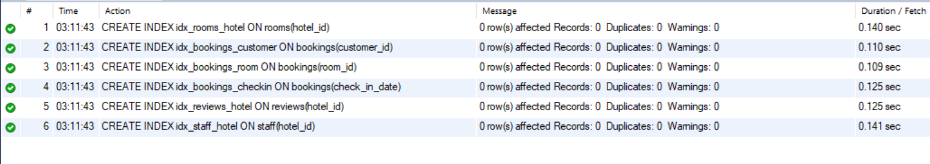 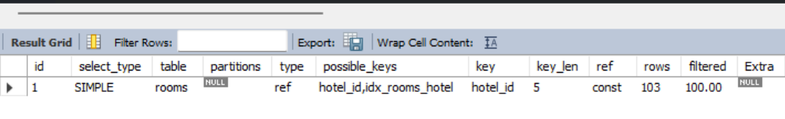

**- Procedures**

**Query:**

DELIMITER //

CREATE PROCEDURE MarkBookingPaid (

IN p_booking_id INT

)

BEGIN

UPDATE bookings

SET payment_status = 'paid'

WHERE booking_id = p_booking_id;

END //

DELIMITER ;

call MarkBookingPaid(1001);

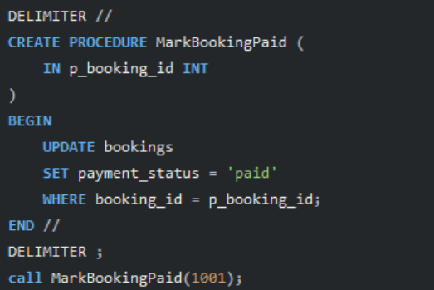

**Output:**

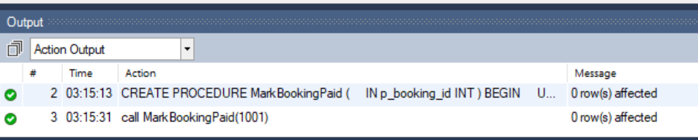

**Query:**

DELIMITER //

CREATE PROCEDURE GetBookingStatusCount()

BEGIN

SELECT payment_status, COUNT(*) AS count

FROM bookings

GROUP BY payment_status;

END //

DELIMITER ;

call GetBookingStatusCount;

**Output:**

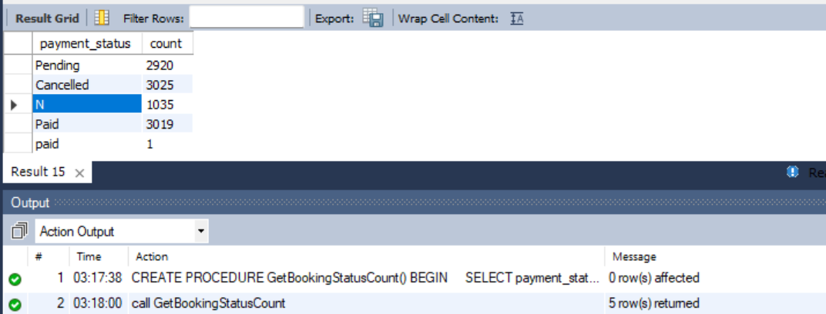

**- Views**

**Query:**

CREATE VIEW view_customer_bookings AS

SELECT b.booking_id, c.full_name, r.room_number, b.check_in_date, b.check_out_date, b.payment_status

FROM bookings b

JOIN customers c ON b.customer_id = c.customer_id

JOIN rooms r ON b.room_id = r.room_id;

select * from view_customer_bookings;

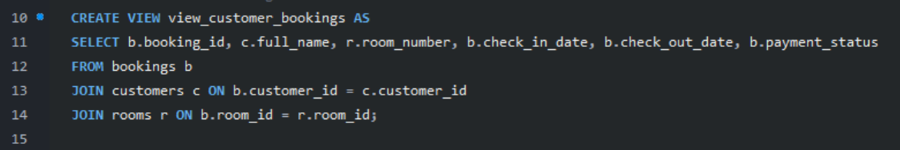

**Output:**

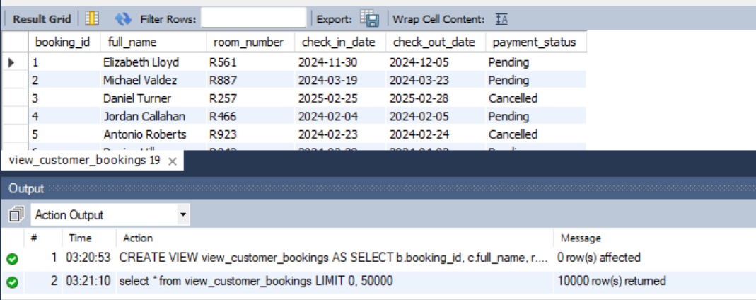

**Query:**

CREATE VIEW view_staff_info AS

SELECT s.staff_id, s.full_name, s.designation, s.salary, h.name AS hotel_name

FROM staff s

JOIN hotels h ON s.hotel_id = h.hotel_id;

Select * from view_staff_info;

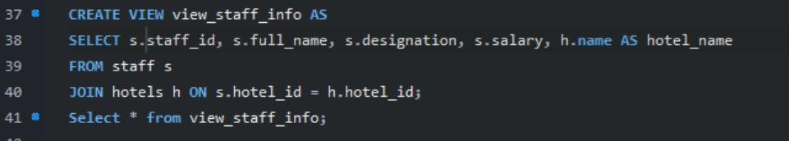

**Output:**

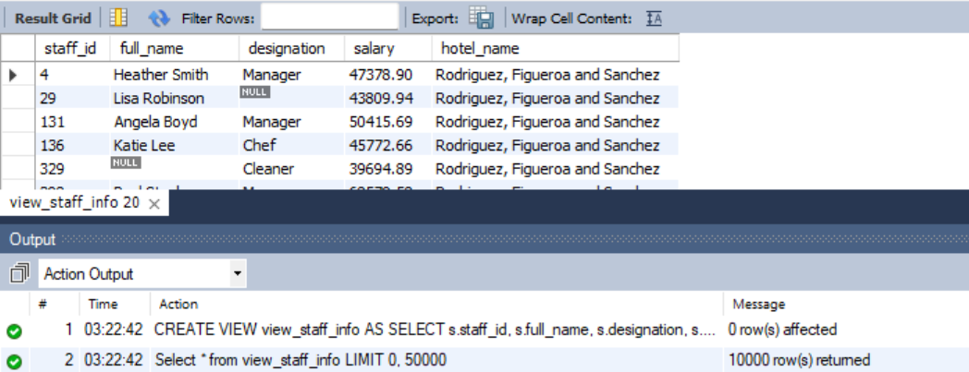

**5. Key SQL Concepts Demonstrated**

| **Concept** | **Example Usage** |
| --- | --- |
| Aggregate Functions | COUNT(), SUM(), AVG(), MIN(), MAX() |
| JOINs | INNER JOIN, LEFT JOIN, etc. |
| Subqueries | WHERE NOT IN (SELECT ...) |
| Constraints | PRIMARY KEY, FOREIGN KEY, CHECK, UNIQUE |
| Transactions | START TRANSACTION, COMMIT, ROLLBACK |
| Indexing | CREATE INDEX ON rooms(availability_status) |

**6. SQL Script Best Practices**

* Used consistent indentation and comments in queries
* Included NULL and duplicate data for robustness testing
* All tables follow 3NF normalization
* No constraint violations in inserted data

**7. Conclusion**

The Hotel Booking Management System project offers a complete simulation of a real-world hotel database. It highlights key SQL features including joins, subqueries, indexing, and transaction handling. With over 10,000 records in each table, the system demonstrates scalability and practical use cases in database design and performance testing.